|  |  |  |  |  |
| --- | --- | --- | --- | --- |
| **WEEK** | **VALUE PROMISE** | **MEMORY VERSE** | **CHARACTER TRAITS** | **WORK HABIT** |
| **ONE** | “I choose to commit and work on time”. | Proverbs 22:6 | 1. Be accountable  2. Obedience  3. Be encouraging  4. Be responsible  5. Be faithful | A goal properly set is half way reached |

Proverbs 22:6 “Train up a child in the way he should go: and when he is old he will he not depart from it”.

Work habit

Name: _________________________________________

Date: __________________________________________

School: _________________________________________

Spellings Corrections

1. 1.

2. 2.

3. 3.

4. 4.

5. 5.

|  |  |  |  |  |
| --- | --- | --- | --- | --- |
| **WEEK** | **VALUE PROMISE** | **MEMORY VERSE** | **CHARACTER TRAITS** | **WORK HABIT** |
| **TWO** | “ I believe in only one God as my God ”. | Matthew 25:35 | 1. Be caring  2. Be responsible  3. Be hospitable  4. Be receptive  5. Have individual responsibility | Do not settle for anything less than excellence |

Matthew 25:35 “For I was hungry and you gave me food I was thirsty and you gave me a drink, I was a stranger, and you invited me in”.

Work habit

Name: _________________________________________

Date: __________________________________________

School: _________________________________________

Spellings Corrections

1. 1.

2. 2.

3. 3.

4. 4.

5. 5.

Theme : **Our environment**

Topic : Soil

Sub topic: How soil is formed?

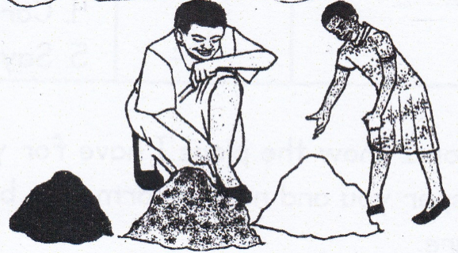 Types of soil and their texture.

Dembe: Excuse me, Rehema, how many types of soil do we have?

Rehema: We have three types. They are clay, sand and loam soil.

Dembe: Which is the best for growing crops?

Rehema: It is loam soil. It has a lot of humus.

Dembe: What is clay and sand soil used for?

Rehema: Clay is used to make pots and sand is used to build houses.

Dembe: Soil is very important we need to protect it.

SOIL: Is the top layer that covers the earth’s surface.

Soil is composed / made up of:-

- Water

- Air (oxygen)

- Rocks particles components of soil

- Humus

- Mineral salts

Experiments on what makes up soil.

(i) Soil contains air.

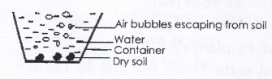

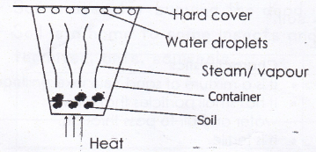(ii) Soil contains water.

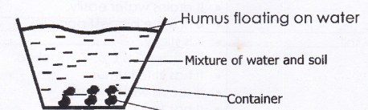 (iii) Soil contains humus (dead plants and animals)

**Mineral salts** are nutrients found in soil that help plants to make food. They are absorbed by roots.

Examples of mineral salts

-Potassium

-Calcium

-Magnesium

-Iron

-Nitrate

**How is humus important?**

- Humus makes the soil fertile

- Humus holds soil particles together.

- Humus makes soil to hold more water and air.

**How is soil important to plants?**

- Plants absorb mineral salts from the soil to form food.

- Soil helps plants to stand firm in the ground.

- Plants grow from soil.

**Types of soil**

|  |  |
| --- | --- |
| Types | Characteristics |
| Loam soil | * lt is a mixture of sand * lt has small particles that allow water and air to pass through * lt is fertile |
| Sand soil | * lt has rough particles * lt has big air spaces * lt drains water easily * lt has the biggest particles |
| Clay soil | * lt is sticky * Particles are closely packed * lt has little humus * lt drains water slowly * lt has fine particles |

**Note:** Loam soil is the best for growing crops because it has a lot of humus.

**How is soil formed?**

* Through decomposition of organic matter
* Through weathering.

**N.B.** Humus is made up of dead rotten or decaying plants and animals.

**Uses of soil to people**

- Some soil is used for painting houses.

- Soil is used for making pots, cups, and plates

- Soil is used for growing crops.

- Soil is used for making bricks.

- Soil is used to build mud houses.

- Soil is used for burying the dead.

- Soil is a home to some insects and animals like; termites, ants, squirrels.

**Activity**

1. What is soil?

2. is the top layer that covers the earth’s surface.

3. How do we call the top layer that covers the earth’s surface?

4. Write down any four components of soil.

i)

ii)

iii)

iv)

5. Which type of soil is best for growing crops?

6. Mention any two living organisms found in the soil.

i)

ii)

7. Why is loam soil the best soil for growing crops?

8. How is clay soil important?

9. Name the three types of soil.

i)

ii)

iii)

10. State any two ways how soil is formed.

i)

ii)

11. Name the three types of soil.

i)

ii)

iii)

**Corrections**

***Score strip***



Checkup 1

Supervisor’s initial ____________

Score _______________

Supervisor’s comment ________________________

PROJECT WORK

Make three groups. Each of the groups will have a different type of soil. Request your teacher for a container, a mineral water bottle and a filter. Cut the top part of the mineral water bottle and get the soil. Each group will put the soil that was given to them in the top part of the mineral water bottle. Put the container under the top part of mineral water bottle and filter.

Get water and pour it in the soil slowly and find out the soil that has more water in the container.

Each team must explain why they received that amount of water.

|  |  |  |  |  |
| --- | --- | --- | --- | --- |
| **WEEK** | **VALUE PROMISE** | **MEMORY VERSE** | **CHARACTER TRAITS** | **WORK HABIT** |
| **THREE** | “I will always be true and do the right things”. | 1st Timothy 4:12 | 1. Be of great integrity & dignity  2. Be truthful  3. Be genuine  4. Endurance & honesty  5. Be bold | Be gentle to all and stern to all |

1st Timothy 4:12 “Do not let anyone look down on you because you are young, but be an example for the believers in your speech your conduct, your love, faith and purity”.

Work habit

Name: _________________________________________

Date: __________________________________________

School: _________________________________________

Spellings Corrections

1. 1.

2. 2.

3. 3.

4. 4.

5. 5.

**Soil profile**

Soil profile is the vertical arrangement of soil layers.

Or

Soil profile is the arrangement of soil layers from the top to bottom.

**A soil profile is made up of three main layers.**

- Top soil

- Sub soil

- Parent rock (they are made of gravel and stone.)

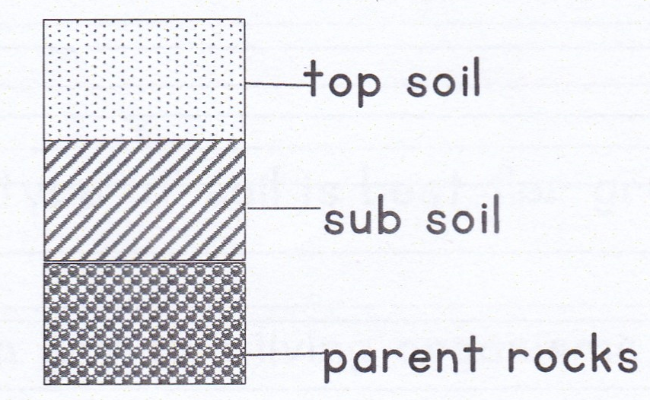**Diagram of the soil profile**

**The top soil**

This is most important layer of the soil

* It allows water and air to pass through to the ground.
* It contains most of the humus and mineral salts needed by the plants.
* Top soil is dark in colour because it contains humus
* Top soil is the best layer for growing crops because it made up of smaller soil particles.

**The sub soil**

* This is a thicker light brown layer of rock pieces, gravel and clay.
* There is no organism or creature found in the sub soil. It is not good for growing crops because it is not fertile.

**Activity**

1. Name the layers of soil in order.

i)

ii)

iii)

2. Draw a diagram to show the arrangement of soil layers.

3. Why is top soil the best layer for growing crops?

4. Which layer is used for crop growing?

5. Which layer is used for building?

6. What is soil profile?

7. What name is given to the vertical arrangement of soil layers?

8. Why is it not advisable to grow crops on sub soil?

**Corrections**

***Score strip***

Name: _________________________________________

Date: __________________________________________

School: _________________________________________

Spellings Corrections

1. 1.

2. 2.

3. 3.

4. 4.

5. 5.

**Self- testing**

1. Define the term soil.

2. Write down the components of soil.

3. State any three uses of soil to man.

i)

ii)

iii)

4. Mention the best soil for growing crops.

5. Which type of soil is used in making glasses?

6. How is soil formed?

7. Name the soil layer that is the best for growing crops.

8. Write down two uses of soil to plants.

i)

ii)

9. Give the meaning of the term soil profile.

10. Draw an experiment to show that soil contains air.

11. Draw the layers of soil profile.

12. What is the commonest way soil is formed?

**Corrections**

***Score strip***

Quiz

1. Write down two uses of soil to plants.

i)

ii)

2. What do use call the decayed plant and animal material in the soil?

3. What is weathering?

4. State any two benefits of sand soil.

i)

ii)

5. Name the type of soil with the poorest drainage ability.

6. What is soil profile?

7. Mention the best soil for pottery.

Some of the new words we have learnt.

|  |  |
| --- | --- |
| **Word** | Meaning |
| Soil | Is the top layer that covers the earth’s |
| Human | Is the dark colour of soil |
| Air | Is the mixture of gases |
| Absorb | Is to suck water and mineral salts from the soil. |
| Decomposition | Is the process of decay caused by bacteria or fungal action. |
| Weathering | Is the process by which rocks break down into small pieces to form soil. |
| Soil profile | Is the vertical arrangement of soil layers |

Name: _________________________________________

Date: __________________________________________

School: _________________________________________

Spellings Corrections

1. 1.

2. 2.

3. 3.

4. 4.

5. 5.

**SUB-THEME: CHANGES IN OUR ENVIRONMENT**

Write down the two types of changes.

1. Natural changes

2. Artificial changes

What are natural changes?

These are changes made by God.

**Write down causes of changes that happen/occur around us.**

**1. Floods**: These are heavy rains over flowing in a place.

**2. Drought**: This is a long period of too much sunshine without

rainfall.

**3. Hail storm**: These are small droplets of ice falling from the sky.

**4. Soil erosion**: lt is the washing away of top soil by its agents.

**5. Lightning**: lt is the flash of light produced by natural electricity between clouds and the ground.

**6. Earthquake**: lt is a sudden violent movement of the earth’s

surface.

**7. Thunder**: This is the noise which follows a flash of lightning.

**8. Volcanic eruption**

**List down the changes that occur in plants**

1. Germination 4. Ripening of fruits

2. Drying of plants /wilting 5. Transpiration

3. Pollination 6. Plant growth

**Write down the changes that take place in the sky**

1. Rising and setting of the sun.

2. Movement of clouds

3. Formation of rainfall.

4. Changes in the moon shapes.

5. Formation of clouds.

6. Changes in weather conditions.

**List down the changes that take place in animals**

|  |
| --- |
| 1. Reproduction 4. Movement  2. Growth 5. Development  3. Moulting 6. Birth  7. Adolescence. |

Activity

1. Write down the two types of changes in the environment.

i)

ii)

2. What are natural changes?

3. State any two examples of natural changes.

i)

ii)

4. Mention any four changes that occur in our environment.

i)

ii)

iii)

iv)

5. Give any two changes that occur in plants.

i)

ii)

6. How do we call the changes made by God?

7. Write down any two changes that take place in the sky.

i)

ii)

8. Give any two changes that take place in animals.

i)

ii)

**Corrections**

***Score strip***

 Checkup 2

Supervisor’s initial __________________

Score _______________

Supervisor’s comment ________________________

|  |  |  |  |  |
| --- | --- | --- | --- | --- |
| **WEEK** | **VALUE PROMISE** | **MEMORY VERSE** | **CHARACTER TRAITS** | **WORK HABIT** |
| **FOUR** | “I choose to do what glorifies the Lord”. | Mathew 7:12 | 1. Be tender & considerate  2. Be loving  3. Be just & kind  4. Be truthful & peaceful  5. Avoid favoritism and being judgmental | Be kind whenever possible. It is always possible |

Mathew 7:12 “Do for others what you would wish them to do for you”.

Work habit

Name: _________________________________________

Date: __________________________________________

School: _________________________________________

Spellings Corrections

1. 1.

2. 2.

3. 3.

4. 4.

5. 5.

**Rusting**

Rusting is when metal turns brownish or yellowish.

Conditions for rusting

- moisture - oxygen

Examples of metals that can rust

* Nails
* Knives
* Keys
* Coins
* Pangas

**Effects / dangers of rusting**

1. Rusting makes sharp objects blunt.

2. Rusting makes metal weak.

3. Rusting makes metal to break.

**Ways of preventing rusting.**

* Painting
* Keeping them in a clean dry place.
* Oiling
* Greasing

**Activity**

1. What is rusting?

2. Give two ways of preventing rusting of metals.

i)

ii)

3. Mention any four dangers of rusting.

i)

ii)

iii)

iv)

4. Give three examples of metals that can rust when exposed to rusting conditions.

i)

ii)

iii)

5. Annet left her hoe outside, in the morning he found it when it had changed its colour. What happened to his hoe?

6. Mention any two effects of rusting

i)

ii)

7. Mention the conditions needed for rusting.

i)

ii)

8. Why is it advisable to paint metals?

9. Why do farmers keep their garden tools in a clean dry place?

**Corrections**

***Score strip***

Name: _________________________________________

Date: __________________________________________

School: _________________________________________

Spellings Corrections

1. 1.

2. 2.

3. 3.

4. 4.

5. 5.

**What is soil erosion?**

Soil erosion is the removal of top soil by its agents.

Agents of soil erosion

* Strong wind
* Fast flowing water
* Moving animals.

**Types of soil erosion**

1. Rill erosion

2. Gulley erosion

3. Sheet erosion

4. Splash erosion

**Causes of soil erosion**

1. Over grazing

2. Bush burning

3. Over stocking of livestock.

4. Deforestation (cutting down of trees).

**How can soil erosion be controlled?**

1. Planting trees 5. Terracing

2. Planting grass 6. Mulching

3. Digging trenches 7. Contour ploughing

4. Strip cropping 8. Growing cover crops like G.nuts

**Mulching**

Mulching is the covering of soil with dry plant materials.

Examples of materials used for mulching.

* Dry grass
* Coffee husks
* Chopped banana stems
* Wood shavings

**Examples of crops that can be mulched**

1. Tomatoes

2. Bananas

**Importance of mulching**

1. Mulching controls soil erosion.

2. Mulching keeps the soil fertile.

3. Mulching keeps water in the soil.

4. Mulching controls the growth of weeds.

**Problems caused by mulching.**

1. Mulches can easily catch fire.

2. Some mulches are hiding places for pests.

3. Some mulches like coffee husks are expensive to get.

**Activity**

1. What is soil erosion?

2. Write down three agents of soil erosion.

i)

ii)

iii)

3. Mention any two types of soil erosion.

i)

ii)

4. State any three causes of soil erosion.

i)

ii)

iii)

5. In which three ways can one control soil erosion.

i)

ii)

iii)

6. How can soil erosion be controlled in hilly areas?

7. How can a farmer control soil erosion in a tomato garden?

8. Mention two ways how to control soil erosion in their compounds.

i)

ii)

9. Give one reason why people plant tree and grass in the compound.

10. What is mulching?

11. Mention any two materials used for mulching.

i)

ii)

12. State any three importances of mulching.

i)

ii)

iii)

13. Write down any two disadvantages of mulching.

i)

ii)

**Corrections**

***Score strip***

Name: _________________________________________

Date: __________________________________________

School: _________________________________________

Spellings Corrections

1. 1.

2. 2.

3. 3.

4. 4.

5. 5.

**Artificial changes**

These are changes made by man.

**Mention the examples of artificial changes**

1. Growing of crops 5. Cutting down of trees

2. Killing of animals 6. Accidents

3. Construction of roads 7. Construction of houses

4. Planting of trees

**The effects of artificial changes**

1. People get shelter from buildings.
2. People get easy transport on roads.
3. People get food from crops grown.
4. People die because of accidents.
5. Rain is formed if trees are planted.
6. Cutting down of trees leads to drought.

**How can the negative artificial changes be controlled?**

|  |  |
| --- | --- |
| **Artificial changes** | **How to control** |
| Deforestation | * Planting more trees. * Putting laws against cutting down trees. * Educating people about the uses of trees. |
| Accidents | * Proper use of road signs. * Avoid reckless driving. * Observing traffic rules. * Avoid grazing animals near the road. * Training drivers. |
| Killing of animals | * Fencing game reserves. * Educating people about the uses of wild animals. * Training more game rangers. * Putting laws against killing wild animals. |

**What is afforestation?**

This is the process of planting trees where they have never been.

**Write down the two types of wood trees.**

1. Soft wood trees

2. Hard wood trees

**What are soft wood trees?**

These are trees which do not last for long and decay so fast e.g. bamboos, pine, wattle(mutuba), cedar, podo, gingko and eucalyptus.

**Uses of soft wood trees**

1. Bamboo and eucalyptus are used for sheltering houses.

2. Mutuba trees provide bark used for making bark cloth.

3. Trees like Musizi are used for making furniture.

4. Wattles are used in making furniture.

5. Used for making match sticks.

**What are hard wood trees?**

These are wood trees that last for so long. They are strong and durable for example Muvule, Mugavu, Mahogany, Oak, Musambya and Musizi.

**Activity**

1. What are artificial changes?

2. are changes made by man.

3. Write down any three examples of artificial changes.

i)

ii)

iii)

4. State any two effects of artificial changes to the people.

i)

ii)

5. How can deforestation be controlled in the environment?

6.What is afforestation?

7. Write down the two types of wood trees.

i)

ii)

8.What are soft wood trees?

9. Give any two examples of soft wood trees.

i)

ii)

10.What are hard wood trees?

**Corrections**

***Score strip***



Checkup 3

Supervisor’s initial _____________________

Score ____________________

Supervisor’s comment ________________________

|  |  |  |  |  |
| --- | --- | --- | --- | --- |
| **WEEK** | **VALUE PROMISE** | **MEMORY VERSE** | **CHARACTER TRAITS** | **WORK HABIT** |
| **FIVE** | “I will always do good to others the way I want them to do for me”. | Proverbs 31: 25 | 1. Be strong and of great dignity  2. Do not be fearful  3. Always work without ceasing  4. Rejoice in the lord and be thankful.  5. Be helpful | Believe you can and you’re halfway there |

Proverbs 31: 25 “She is strong and of dignity; she is not afraid of the future”.

Work habit

Name: _________________________________________

Date: __________________________________________

School: _________________________________________

Spellings Corrections

1. 1.

2. 2.

3. 3.

4. 4.

5. 5.

SELF TESTING EXERCISE

1. Write down the two types of changes.

i)

ii)

2. Give the meaning of each type of change mentioned in question (1)

3. Write down four types of natural changes that occur in our environment.

i)

ii)

iii)

iv)

4. How can the following natural changes be controlled?

a) Floods

b) Soil erosion

c) Rusting of metals

5. Write down any three changes that occur in plants.

i)

ii)

iii)

6. Give the meaning of the term soil erosion

7. Write down three causes of soil erosion.

i)

ii)

iii)

8. What is mulching?

9. Write down four examples of artificial changes.

i)

ii)

iii)

iv)

10. Mention at least three effects of artificial changes.

i)

ii)

iii)

11. What do the following terms mean?

a) Hard wood

b) Soft wood

12. Give two examples of each type of wood.

i)

ii)

Quiz

1. Give two changes that take place in plants.

i)

ii)

2. State any two dangers of drought.

i)

ii)

3. Write down two examples of materials used for mulching.

i)

ii)

4. Mention two bad practices that destroy the environment.

i)

ii)

b. Give two solutions to the bad practices mentioned in 4a) above.

i)

ii)

5. How does grass help to control soil erosion?

6. Which areas are mostly affected by landslides?

b) State any two dangers of landslides.

i)

ii)

7. What happens when wind moves at a very high speed?

**Some of the new words we have learnt.**

|  |  |
| --- | --- |
| **word** | **Meaning** |
| 1. Change | ls a fact of life. |
| 2. Natural changes | Are changes made by God. |
| 3. Floods | These are heavy rains over flowing in a place. |
| 4. Drought | ls a long period of too much sunshine without rain. |
| 5.Hail storm | These are small droplets of ice falling from the sky. |
| 6. Soil erosion | ls the washing away of top soil by its agents. |
| 7. Lightning | ls the flash of light produced by natural electricity between clouds and the ground. |
| 8. Earth quake | ls a sudden violent movement of the earth’s surface. |
| 9. Thunder | ls the noise which follows a flash of lighting. |
| 10.Germination | ls the growing of seed embryo into a seedling. |
| 11. Pollination | ls the transfer of pollen grains from the anther to the stigma. |
| 12.Transpiration | ls the process by which plants lose water to the atmosphere. |
| 13. Reproduction. | ls the process of generating of off springs. |
| 14. Growth | ls increase in size, height in living things. |
| 15. Moulting | ls the shedding off of the outer skin in reptiles. |
| 16. Rusting | ls a brownish or yellowish substance on metal. |
| 17. Mulches | Are things used in mulching. |
| 18. Soft wood | ls the wood got from planted trees. |
| 19. Hard wood | ls the wood got from natural trees. |

***Score strip***

Name: _________________________________________

Date: __________________________________________

School: _________________________________________

Spellings Corrections

1. 1.

2. 2.

3. 3.

4. 4.

5. 5.

**SUB THEME: CHANGES IN THE ATMOSPHERE.**

**What is weather?**

This is the condition of the atmosphere at a given time and place.

**Six types of weather**

1. Windy weather

2. Foggy weather

3. Sunny weather

4. Rainy weather

5. Cloudy weather

6. Misty weather

**Elements of weather**

1. Wind

2. Sunshine

3. Rainfall

4. Cloud cover

5. Humidity

6. Temperature

**N.B** Clouds is the combination of dust, water and smoke that float in the sky.

**Write down the importance of each element of weather.**

|  |  |
| --- | --- |
| Element | Importance |
| Rainfall | * lt provides rain water to animals. * lt provides rain water for domestic use. * lt makes the weather cool. * lt makes the soil soft for digging. |
| Sunshine | * lt dries seeds. * lt provides heat for drying clothes. * lt helps the skin to get Vitamin D. * lt helps plants to make food. |

|  |  |
| --- | --- |
| Wind | * lt helps in winnowing. * lt drives away bad air. * lt helps in pollination. |
| Clouds | * lt makes the weather cool. * Nimbus clouds form rainfall. |

**Seasons**

**A season** is a period when an area receives the same weather conditions for a long time.

**Name the two seasons in Uganda.**

1. Wet seasons : An area receives a lot of rain.

2. Dry seasons : An area receives too much sunshine.

**Write down the activities done in each season.**

|  |  |
| --- | --- |
| Wet season | Dry season |
| * Planting seeds * Weeding * Transplanting * Thinning * Pruning | * Land clearing * Harvesting * Drying seeds * Sorting seeds * Storing food |

**Activity**

1. Give the meaning of the term weather.

2. Write down the two seasons in Uganda.

i)

ii)

3. Mention any four types of weather.

i)

ii)

iii)

iv)

4. Mention the four elements of weather.

i)

ii)

iii)

iv)

5. In which season do farmers harvest their crops?

6. Name the best season for growing crops.

7. Name the types of weather when people use umbrellas.

8. Mention the importance of the following;

a) Rainfall

b) Sunshine

9. Write down the dangers of;

a) Too much wind

i)

ii)

b) Too much rainfall

i)

ii)

10.Which element of weather makes murram roads slippery?

11.What is meant by the term season?

12. Write down any two activities done in the rainy season.

i)

ii)

13. Mention any two activities done in dry season.

i)

ii)

**Corrections**

***Score strip***



Checkup 4

Supervisor’s initial __________

Score _________________

Supervisor’s comment ________________________

|  |  |  |  |  |
| --- | --- | --- | --- | --- |
| **WEEK** | **VALUE PROMISE** | **MEMORY VERSE** | **CHARACTER TRAITS** | **WORK HABIT** |
| **SIX** | “I choose to impact other people’s lives positively”. | Exodus 20: 12 | 1. Be respectful & obedient  2. Always appreciate your parents  3. Be a good listener  4. Be proud of your parents  5. Always respect and listen to your parents | Always do your best, What you plant now, you will harvest later |

Exodus 20:12 “Respect your father and your mother so that you may live a long time in the land that I am giving you”.

Work habit

Name: _________________________________________

Date: __________________________________________

School: _________________________________________

Spellings Corrections

1. 1.

2. 2.

3. 3.

4. 4.

5. 5.

**AIR**

**Air** is a mixture of gases.

(Components / parts of air)

|  |  |
| --- | --- |
| Rare gases or noble gases | * lt is composed of the other gases like helium, neon, argon, krypton and xenon. |
| Nitrogen | * lt has the biggest percentage. * lt is used in bulbs. |
| Oxygen | * lt is the gas we breathe in. * lt supports burning. * lt supports germination. |
| Carbon dioxide | * lt is the gas we breathe out. * lt is used by plants to make food * lt is used to put out fire. * lt is used to preserve soft drinks like soda. |

**Show the gas percentages in the atmosphere.**

Oxygen - 21%

Rare gases - 0.97%

Carbon dioxide - 0.03%

Nitrogen - 78%

**Name the gas with the smallest percentage.**

Carbon dioxide has the smallest percentage.

**Properties of air**

1. Air has weight.

2. Air exerts pressure.

3. Air occupies space.

4. Air can be compressed

**Use diagrams to show the properties of air.**

**Air has weight**

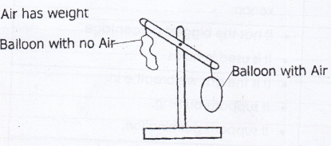

**Observation**: The balloon with air goes down because air has weight.

**Air exerts pressure**

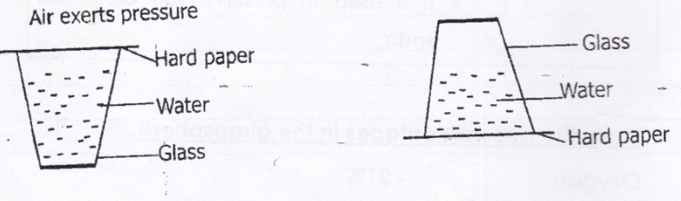

**Observation**

When the glass was turned upside down. The hard paper did not fall off because the Air pressure pushed it up. When taking a drink e.g. splash using straw, the pressure pushes the drink up the straw.

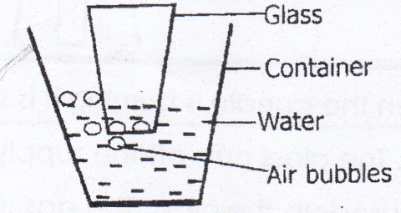**(iii) Air occupies space**

**Observation:** Air bubbles are seen escaping from water.

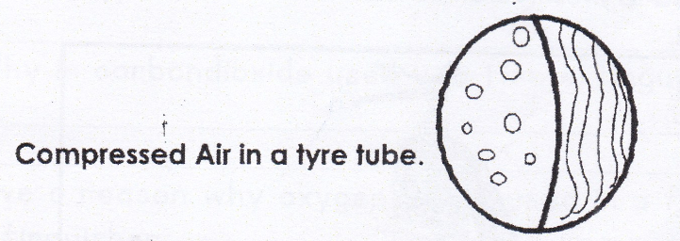**(iv) Air can be compressed.**

Compressed air is used in car tyres to support the weight of the car. lt is also used in balls, balloons, floats and sprays.

**List down the uses of air.**

Oxygen : -lt supports life (breathing, respiration)

- lt supports burning.

- lt supports germination.

**How is germination and respiration similar?**

Both use oxygen.

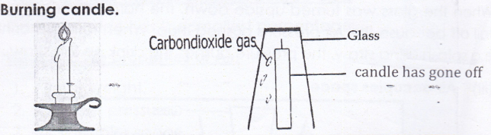**Use an experiment to show that air supports burning.**

**Observation:** When the candle is burning it is supported by oxygen. The glass cuts off the supply of oxygen and then it is gets used up by the glass. The gas that remains is carbon dioxide which blows the candles off.

**Carbon dioxide:**

_ It puts off fire because it does not support burning .

_ It helps a plant to make its own food (photosynthesis).

_ It is used to preserve drinks like soda, beer and food tinned.

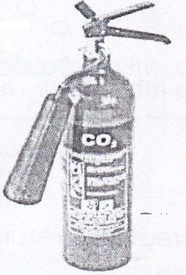

**A fire extinguisher uses carbon dioxide gas to put out fire.**

**Nitrogen:** - it helps in formation of artificial fertilizers

- it provides nutrients to plants through minerals.

**Rare gases:** -it is used in electrical bulbs

**Activity**

1. What is air?

2. What do we call the mixture of gases?

3. Which type of air is use in a fire extinguisher?

4. Why is carbon dioxide used in a fire extinguisher?

5. Give a reason why oxygen is not used in a fire extinguisher.

6. How is germination and rusting similar?

7. Mention the four components of air.

i)

ii)

iii)

iv)

8. State down four properties of air.

i)

ii)

iii)

iv)

9. Draw and name any three properties of air.

|  |  |  |
| --- | --- | --- |
|  |  |  |
|  |  |  |

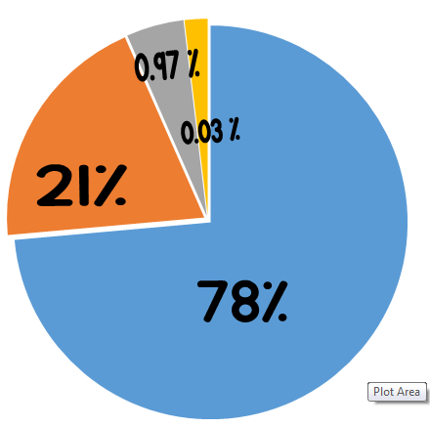10. Use the diagram below to answer the questions that follow.

a) Which component of air has;

i) 78%

ii) 21%

iii) 0.9%

iv) 0.03%

b) Name the component of air with;

i) highest percentage

ii) lowest percentage

11. Which component of air;

i) supports burning

ii) helps in formation of fertilizers

iii) is in fire extinguishers

iv) is used in making electric bulbs.

**Corrections**

***Score strip***



Checkup 5

Supervisor’s initial __________

Score __________

Supervisor’s comment ________________________

PROJECT WORK

a) Request your teacher for powder, a mineral water bottle and a container. Make a hole in the bottle and put in the powder in the bottle. Get a straw, put it in the hole and squeeze the bottle. What will come out?

Explain the property it is.

b) As you have learnt, in your groups conduct a practical experiment of air exerts pressure.

|  |  |  |  |  |
| --- | --- | --- | --- | --- |
| **WEEK** | **VALUE PROMISE** | **MEMORY VERSE** | **CHARACTER TRAITS** | **WORK HABIT** |
| **SEVEN** | “I choose to be at peace and have good team work”. | Psalm 127:3-5 | 1. Be responsible  2. Be God fearing  3. Be compassionate to your children  4. Be obedient & respect for children  5. Cherish the glory of your children | Discipline is the bridge between goals and accomplishment |

Psalm 127:3-5 “Children are a gift from the lord, they are a real blessing like arrows in the hands of a warrior, are children born in one’s youth”.

Work habit

Name: _________________________________________

Date: __________________________________________

School: _________________________________________

Spellings Corrections

1. 1.

2. 2.

3. 3.

4. 4.

5. 5.

**Wind**

**What is meant by the word wind?**

Wind is moving air.

OR

Wind is air in motion.

**Write down the uses of wind**

1. Wind moves things like boats and kites.

2. Wind is used in winnowing.

3. Wind dries clothes.

4. Wind cools our bodies.

5. Wind moves wind mills.

6. Wind helps in sailing of boats.

**Dangers of wind**

1. Strong wind destroys crops

2. Strong wind blows off the roofs of houses

3. Wind rises dust

4. Wind causes soil erosion

5. Wind spreads diseases like whooping cough

6. Strong wind destroys crops

7. Strong wind breaks tree branches or trees

**SELF TESTING EXERCISE.**

1. What is meant by the term air.

2. Which form of air has the biggest percentage in the

atmosphere?

3. List down the properties of air.

i)

ii)

iii)

4. With an illustration, show that air exerts pressure.

5. Write down the various forms of air.

6. Give the importance of air to man.

7. What is meant by the term wind.

8. State any four uses of wind

i)

ii)

iii)

iv)

9. Write down any three dangers of wind.

i)

ii)

iii)

10. Name the form of air that has the least percentage

atmosphere.

11. Which gas is used to put out fire?

12. Which type of weather is winnowing done?

13. How do we call air in motion?

**Corrections**

***Score strip***

Name: _________________________________________

Date: __________________________________________

School: _________________________________________

Spellings Corrections

1. 1.

2. 2.

3. 3.

4. 4.

5. 5.

**THE SUN**

1. The sun is the main natural source of light.

2.The sun provides solar, heat and light energy.

3.lt rises from the east direction and sets in the west.

4. When the sun is blocked, a shadow is formed in the opposite direction of the sun.

Write down other natural sources of light.

1. Stars

2. Glow worm

3. Fire flies

4. Lightning flash

**Note:** The moon is not a natural source of light because it

reflects light from the sun.

**Mention the artificial sources of light.**

1. Torches 2. Electric bulbs

3. Candles 4. Match boxes

5. Car head lamps

**State the uses of the sun to man.**

1. The sun provides light

2. The sun helps people to tell direction

3. The sun helps in formation of rainfall

4. The sun is a source of solar energy

5. The sun helps our skin to make vitamin D

6. The sun helps plants to manufacture (make) food

7. The sun helps plants to grow well

**State the dangers of the sun.**

1. Prolonged sunshine causes drought

2. Too much sunshine dries water bodies

3. Too much sunshine makes the soil hard for ploughing

4. Too much sunshine can cause temperatures to rise

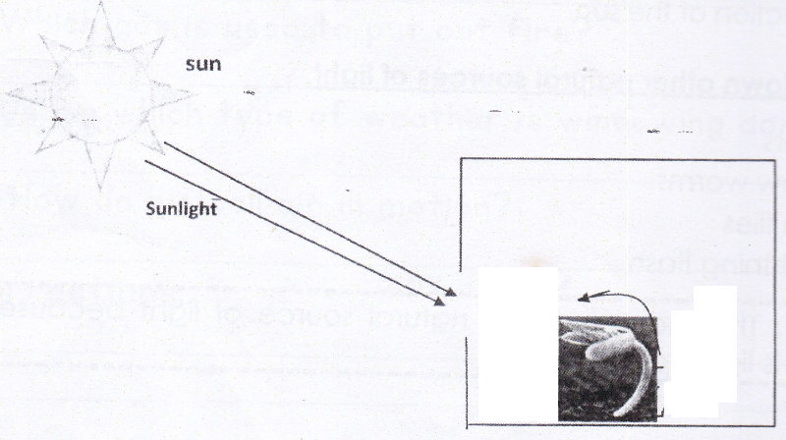What does the experiment below show?

This experiment shows that a plant needs sunlight in order to grow well. That is why this plant is bending towards sunlight.

**Draw a shadow and show parts of a shadow.**

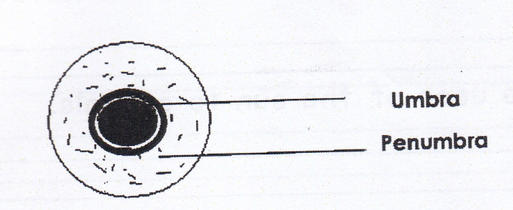

**List down the characteristics of shadows**

1. Shadows have two parts (Umbra and Penumbra).

2. Penumbra is partial darkness while umbra is total darkness.

3. Shadows are always formed on the opposite side of light.

4. Shadows appear shortest at noon.

5. Shadows appear longest in the early morning and late evening.

**Suggest three uses of shadows.**

1. Shadows help us to tell time.

2.Shadows show direction.

3.Shadows give us shades.

**Activity**

1. In which direction does the sun set?

2. Apart from the sun, write down other natural sources of

light.

3. Name the kind of energy produced by the sun.

4. Write down three uses of the sun to animals.

i)

ii)

iii)

5. Write down at least two dangers of the sun.

i)

ii)

6. Mention at least two characteristics of shadows.

i)

ii)

7. Name the two parts of the shadow.

i)

ii)

8. State any two uses of shadows.

i)

ii)

9. Why isn’t the moon a natural source of light?

10. Name the darker part of a shadow.

11. At what time does the shadow appear?

a)Longest

b)Shortest

12. How does the shadow appear when the sun is over headed?

**Corrections**

***Score strip***

Name: _________________________________________

Date: __________________________________________

School: _________________________________________

Spellings Corrections

1. 1.

2. 2.

3. 3.

4. 4.

5. 5.

**SUB-THEME :WATER**

**1. Name the main natural source of water.**

Rain

**2. Name other sources of water.**

1. Rivers 4. Tanks 7. Springs

2. Lakes 5. Boreholes 8. Swamps

3. Wells 6. Taps 9. Dams etc.

**3. How is rain formed?**

1. Rain is formed through a process known as a **water cycle.**

2.The sun heats the water body.

3. The water heats up and starts evaporating.

4. The vapor rises up and then condenses to form nimbus clouds

5. The condensed vapor becomes heavy and then falls down as rain.

**A diagram showing the water cycle.**

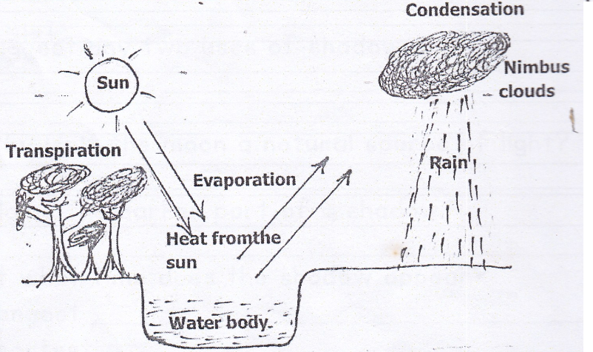

Processes involved in the rain cycle.

**1. Transpiration**: This is the process when plants lose water

to the atmosphere through leaves.

2. Evaporation: This is the process when water rises to the atmosphere in form of vapor.

3. Condensation: This is the process when water vapor cools to form rainfall.

**Note:** An instrument used to measure the amount of rain received is a rain gauge.

**Why is the rain important?**

1. Animals get water for drinking.

2. Man gets water for domestic use.

3. Rain fills water bodies.

4. Rain cools weather.

5. Rain water helps in generating hydro electricity.

6. Rain makes the soil soft.

**Dangers of rain.**

1. Too much rainfall causes floods.

2. Too much rainfall destroys crops.

3. Too much rainfall destroys buildings and roads.

4. Too much rainfall causes soil erosion.

5. Too much rainfall kills animals.

**Activity**

1. Name the main natural source of water.

2. Mention any other three sources of water apart from rain.

i)

ii)

iii)

3. What is a water cycle?

4. Mention the three processes involved in the cycle/rain cycle.

i)

ii)

iii)

iv)

5. State any three uses of rain in our environment.

i)

ii)

iii)

6. Give any three dangers of rain in the environment.

i)

ii)

iii)

7. Write down any three uses of water.

i)

ii)

iii)

8. Match correctly.

|  |  |
| --- | --- |
| Transpiration | the process by which vapor change to water. |
| Evaporation | the process by which plants lose water to the atmosphere in form of vapour |
| Condensation | the process by which water change to vapour. |

Transpiration

Evaporation

Condensation

9. Which instrument is used to measure the amount of rainfall received in an area?

**Corrections**

***Score strip***



Checkup 6

Supervisor’s initial __________

Score ________________

Supervisor’s comment ________________________

PROJECT WORK

Draw a picture which talks about a rain cycle. You can design it using any material.

|  |  |  |  |  |
| --- | --- | --- | --- | --- |
| **WEEK** | **VALUE PROMISE** | **MEMORY VERSE** | **CHARACTER TRAITS** | **WORK HABIT** |
| **EIGHT** | “I believe God will always help me to be a good leader”. | Mathew 20 : 27 -28 | 1. Be a good leader  2. Do not be judgmental  3. Be kind and patient  4. Seeks God’s approval always  5. Be responsible | Discipline is what you must have to resist the lies of excuses |

Mathew 20 : 27 -28 “And whoever would be first among you must be your slave, even as the son of man came not to be served but to serve and to give life as a ransom for many”.

Work habit

Name: _________________________________________

Date: __________________________________________

School: _________________________________________

Spellings Corrections

1. 1.

2. 2.

3. 3.

4. 4.

5. 5.

**The two types of water sources**.

i. Natural sources or God made sources like rain, well, springs, lakes, rivers, sea and oceans.

ii. Artificial sources or manmade sources like, boreholes, pipe water likes taps and fountain jets.

Picture of girl getting water from bore hole

**How can water sources be protected?**

1. Fencing them

2. Putting laws

3. Adding chlorine to water sources to kill germs.

4. Proper disposal of human wastes.

5. Planting grass around them.

**Write the ways of harvesting water.**

* Tanks
* Jerry cans
* Basins
* Saucepans

**Name other types clouds apart from nimbus clouds.**

1. Stratus clouds 3. Cumulus clouds

2. Cirrus clouds

**Write short notes on each type of clouds:**

**Nimbus clouds:** They are dark grey in color and appear

nearest the earth. They bring rain.

**Stratus clouds:** They are a sign of fair weather.

**Cirrus clouds**: They appear furthest in the sky. They look like

feathers.

**Cumulus clouds**: They are white in colour and they resemble

cotton piles.

**What are weather instruments?**

These are instruments that are used to measure or show different weather conditions.

They are found at weather stations.

**Activity**

1. Name the main natural source of water.

2. How can water sources be protected?

3. Write down at least four importance’s of rain.

i)

ii)

iii)

iv)

4. Give any two dangers of rain.

i)

ii)

5. Which clouds give us rain?

6. Mention the four types of clouds.

i)

ii)

iii)

iv)

7. Mention the clouds that appear highest in the sky.

8. Name the instrument used to measure the amount of rain

received.

9. How are nimbus clouds useful to a farmer?

10. Write down any three artificial sources of water.

i)

ii)

iii)

11. Write the two types of water sources.

i)

ii)

12. Give examples of natural sources of water.

13. State any three examples of water.

i)

ii)

iii)

**Corrections**

***Score strip***

Name: _________________________________________

Date: __________________________________________

School: _________________________________________

Spellings Corrections

1. 1.

2. 2.

3. 3.

4. 4.

5. 5.

**Weather instruments.**

What are weather instruments?

These are instruments that are used to measure or show different weather conditions.

They are found at weather stations

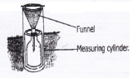**Rain gauge:** It is used to measure the depth of rain in the soil

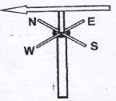**Wind vane:** It is used to show direction of wind

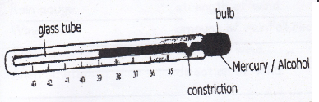**Thermometer** it is used to measure temperature.

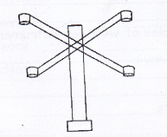**An anemometer:** It measures the speed of wind

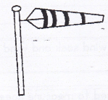**Wind sock:** It shows the strength of wind

**Activity**

1. What is a weather station?

2. Write down any three examples of weather instruments.

i)

ii)

iii)

3. What are weather instruments?

4. How is a thermometer useful?

5. Give the difference between a wind sock and a wind vane.

6. Which weather instrument is used to measure speed of wind?

7. Mention any two liquids that can be used in a thermometer.

i)

ii)

8.Match the following correctly.

Rain gauge strength of wind.

Wind vane amount of rainfall received

Thermometer speed of wind

Anemometer direction of wind

Wind sock

Rain gauge

Wind vane

Thermometer

Anemometer

**Corrections**

***Score strip***

**Some of the new words we have learn**

|  |  |
| --- | --- |
| **word** | **meaning** |
| 1. weather | is the condition of the atmosphere at a given time and place |
| 2. season | is a period when an area receives the same weather condition for a long time. |
| 3. clouds | are a combination of dust, water and smoke that float the sky. |
| 4. air | is the mixture of gases. |
| 5. wind | is moving air or air in motion. |
| 6. winnowing | is the act of separating grain from chaff/ dirt. |
| 7. umbra | is a dark part of a shadow. |
| 8. penumbra | is the light part of a shadow |
| 9. shadow | is the dark area formed when light is obstructed by an opaque object |
| 10. opaque object | is an object which does not allow light to pass through. |
| 11. transpiration | is the process by which plants lose water to the atmosphere. |
| 12. condensation | is a process by which vapor changes to water |
| 13. evaporation | is a process by which water changes to vapour |

***Score strip***

Name: _________________________________________

Date: __________________________________________

Spellings Corrections

1. 1.

2. 2.

3. 3.

4. 4.

5. 5.

**Sanitation**

What is sanitation?

Sanitation is the general cleanliness of the environment.

Importance’s of good sanitation.

Good sanitation promotes good public health.

Good sanitation control vectors.

Good sanitation prevents the spread of germs.

Good sanitation prevents bad smell in the environment.

**Why is poor sanitation bad?**

1. It brings bad smell.

2. It can bring sicknesses in a home.

3. It can bring vectors like files etc

**Suggest ways in which sanitation can be promoted.**

1. Building plate stands

2. Cleaning latrines or toilets regularly

3. Proper disposal of rubbish

4. Slashing bushes around our homes.

5. Draining away stagnant water.

6. Fencing water sources.

**Write down the things used in keeping proper sanitation:**

1. Brooms 5. Brushes

2. Soap 6. Wheel barrow

3. Dustbins 7. Spades

4. Rakes

**What are qualities of a good home?**

**A good home should have:**

1. Compound 4. A latrine or toilet

2. Rubbish pit 5. Plate stand

3. Kitchen 6. Proper ventilation

**Write down the qualities of a good house.**

1. widows 4. doors

2. ventilators 5. verandah

3. strong roof

**Activity**

1. Give the meaning of the term sanitation.

2. Name any three things used to promote proper sanitation.

i)

ii)

3. State any three ways we can promote proper sanitation.

i)

ii)

iii)

4. Write down any two importance’s of promoting sanitation.

i)

ii)

5. Identify four qualities of a good house.

i)

ii)

iii)

iv)

6. Mention five qualities of good house.

i)

ii)

iii)

iv)

v)

7. Give difference between sanitation and personal hygiene.

8. How is wind important in promotion of sanitation?

**Corrections**

***Score strip***

Quiz

1. Mention two processes involved in rain formation.

i)

ii)

2. Name the two parts of a shadow.

i)

ii)

3. Name the gas that occupies the largest part of the atmosphere.

4. Which property of air helps people to drink soda using a straw?

5. Mention the gas used in preserving soda.

6. Mention the weather condition that helps farmers in winnowing seeds.

7. Name the type of cloud that looks like cotton piles.

8. Name the type of clouds that are a sign of rainfall.

9. What causes water to evaporate?

Some of the new words we have learnt

|  |  |
| --- | --- |
| Word | Meaning |
| 1. sanitation | is the general cleanliness of our environment. |
| 2. vectors | are living organisms which spread diseases/ germs. |
| 3. germs | are tiny living organisms which cause diseases. |
| 4. house | is a habitat of people |
| 5. personal hygiene | is the general cleanness of the body and the things we use |
| 6. latrines / toilets | are places where human wastes are disposed of properly . (for proper of human wastes) |
| 7. stagnant water | is a collection of water in a place that is not flowing. |

**Corrections**

***Score strip***



Checkup 7

Supervisor’s initial __________

Score ___________

Supervisor’s comment ________________________

PROJECT WORK

Request your teacher for cotton wool, plain paper and an atlas and look out for clouds in the atlas. Once you find the clouds in the atlas look out for the clouds you learnt about. Get the cotton wool and form them into shapes according how they look. Paste them on the paper. You are allowed to use soil but according to how the cloud looks like.

In your groups, request your teachers to teach you how to make a wind sock.